Measuring Tape
# Source: AI Source: Provided by: [Data Path: Persons Table -> ID Column: 1, Name_En Column: Motasem Essam] -> From: [ChatGPT] on [7/17/2026]
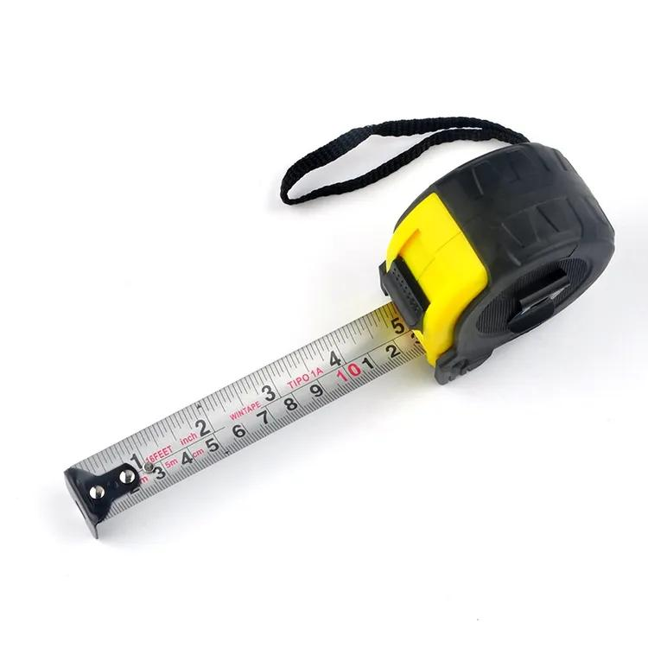
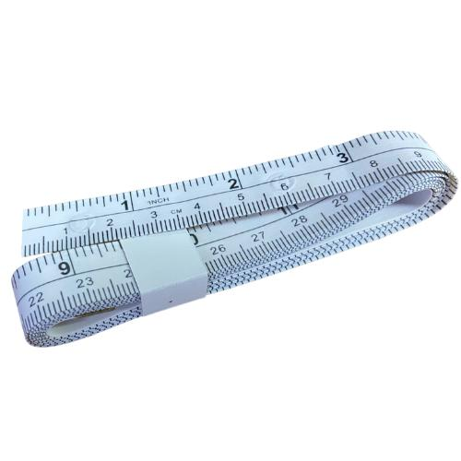
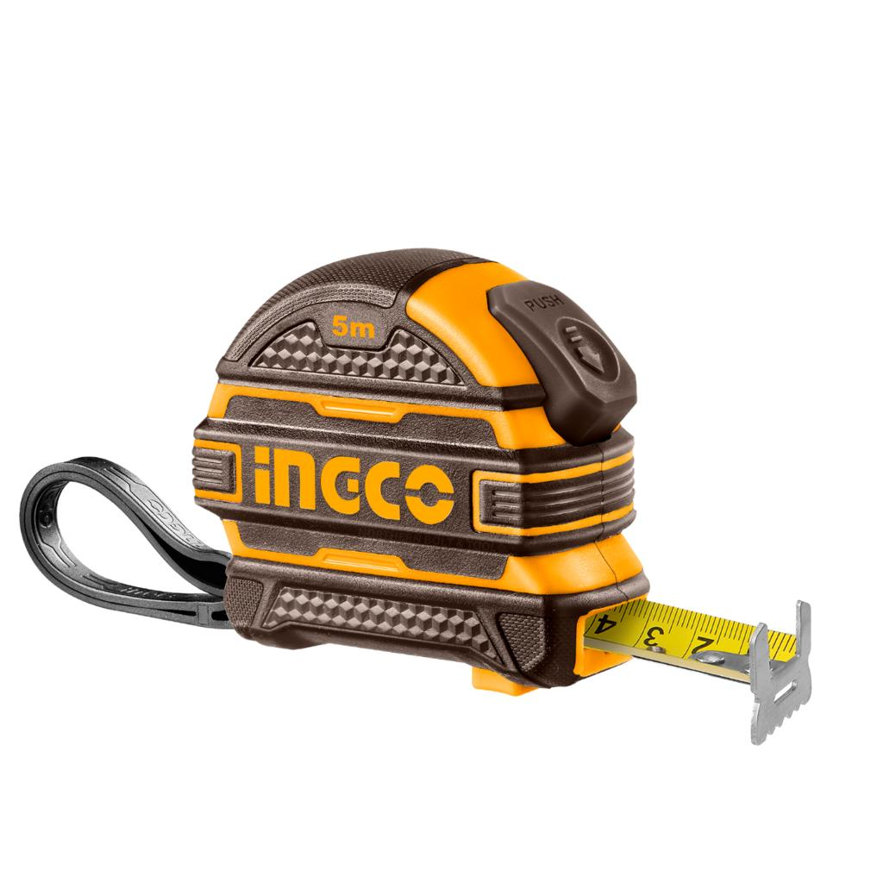
A Measuring Tape (also called a tape measure) is a flexible measuring instrument used to measure length, width, height, distance, circumference, and curved surfaces. Unlike a rigid ruler, a measuring tape can bend and extend over long distances, making it suitable for a wide variety of applications.
Measuring tapes are widely used in construction, engineering, architecture, tailoring, woodworking, surveying, manufacturing, and everyday household tasks.

Definition
# Source: AI Source: Provided by: [Data Path: Persons Table -> ID Column: 1, Name_En Column: Motasem Essam] -> From: [ChatGPT] on [7/17/2026]
A measuring tape is a flexible measuring instrument marked with graduated units and used to measure linear dimensions, long distances, and curved surfaces.

Purpose
# Source: AI Source: Provided by: [Data Path: Persons Table -> ID Column: 1, Name_En Column: Motasem Essam] -> From: [ChatGPT] on [7/17/2026]
A measuring tape is used to:
- Measure length.
- Measure width.
- Measure height.
- Measure circumference.
- Measure curved objects.
- Measure room dimensions.
- Measure long distances.
- Assist in layout and construction work.

Construction
# Source: AI Source: Provided by: [Data Path: Persons Table -> ID Column: 1, Name_En Column: Motasem Essam] -> From: [ChatGPT] on [7/17/2026]
A typical measuring tape consists of:
- Flexible measuring blade or tape
- Graduated measurement scale
- Zero reference hook or end
- Housing (for retractable types)
- Locking mechanism (on retractable models)
- Return spring (on retractable models)

Common Materials
# Source: AI Source: Provided by: [Data Path: Persons Table -> ID Column: 1, Name_En Column: Motasem Essam] -> From: [ChatGPT] on [7/17/2026]
Measuring tapes may be made from:
- Steel
- Fiberglass
- Cloth
- Plastic-coated steel
- Vinyl
- Reinforced fabric

Types of Measuring Tape

1. Retractable Measuring Tape
# Source: AI Source: Provided by: [Data Path: Persons Table -> ID Column: 1, Name_En Column: Motasem Essam] -> From: [ChatGPT] on [7/17/2026]

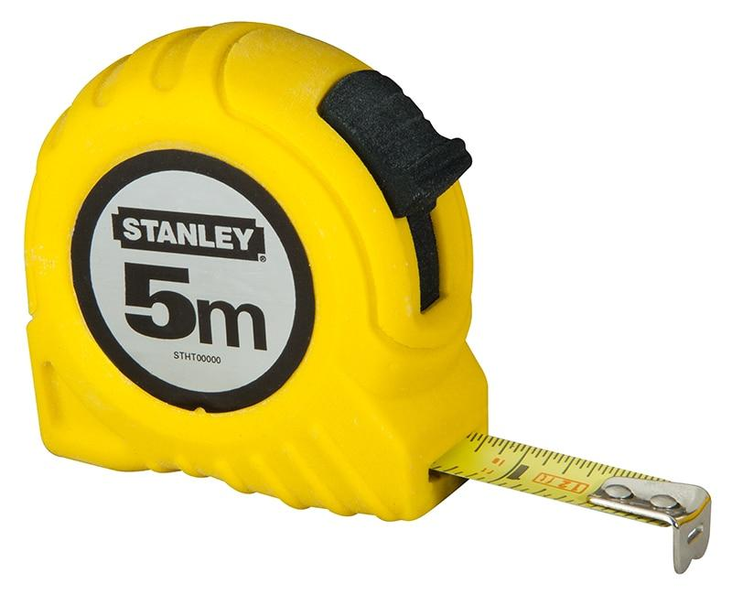

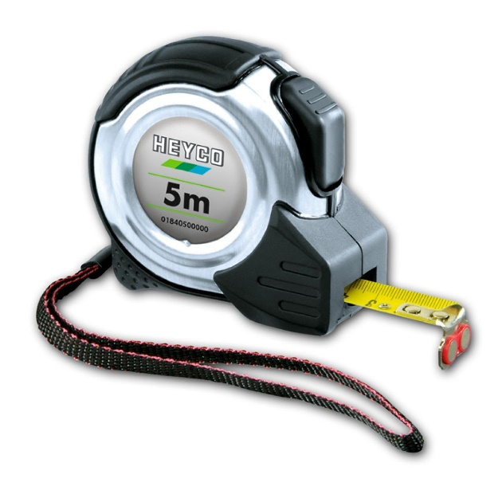
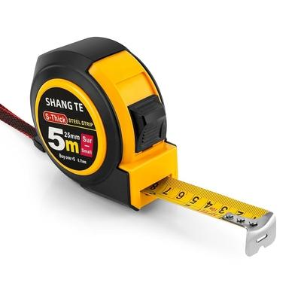
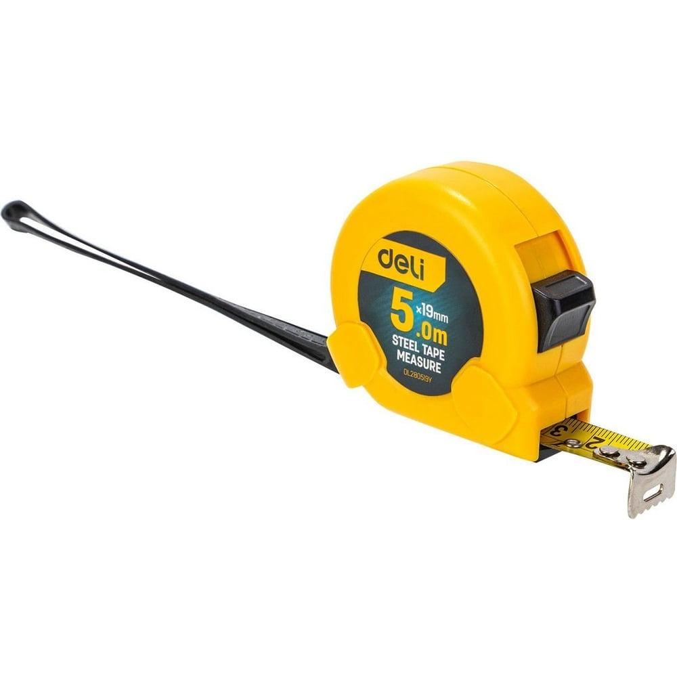
Description
A Retractable Measuring Tape is a spring-loaded measuring tape stored inside a protective case. The tape extends when pulled and automatically retracts when released.
Features
- Steel measuring blade
- Protective housing
- Spring-return mechanism
- Lock button
- Belt clip (on many models)
Typical Length
- 2–10 m (6–33 ft)
Common Uses
- Construction
- Carpentry
- Home improvement
- Engineering
- Interior measurements

2. Flexible Tailor's Tape
# Source: AI Source: Provided by: [Data Path: Persons Table -> ID Column: 1, Name_En Column: Motasem Essam] -> From: [ChatGPT] on [7/17/2026]
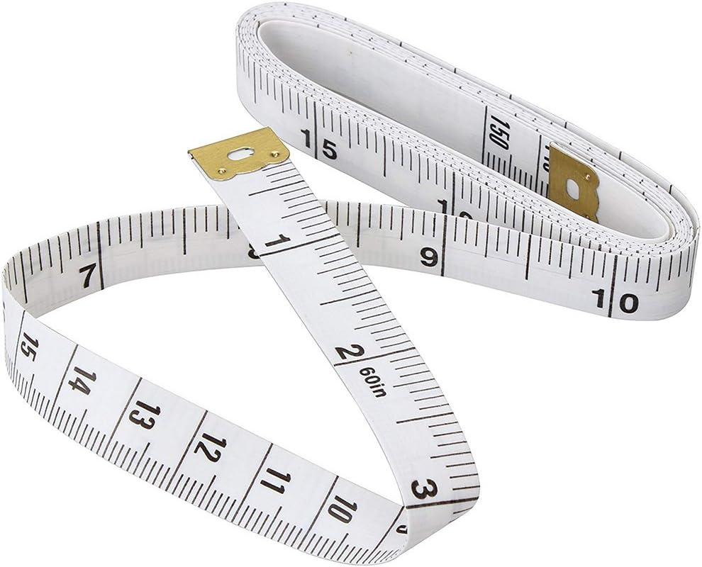
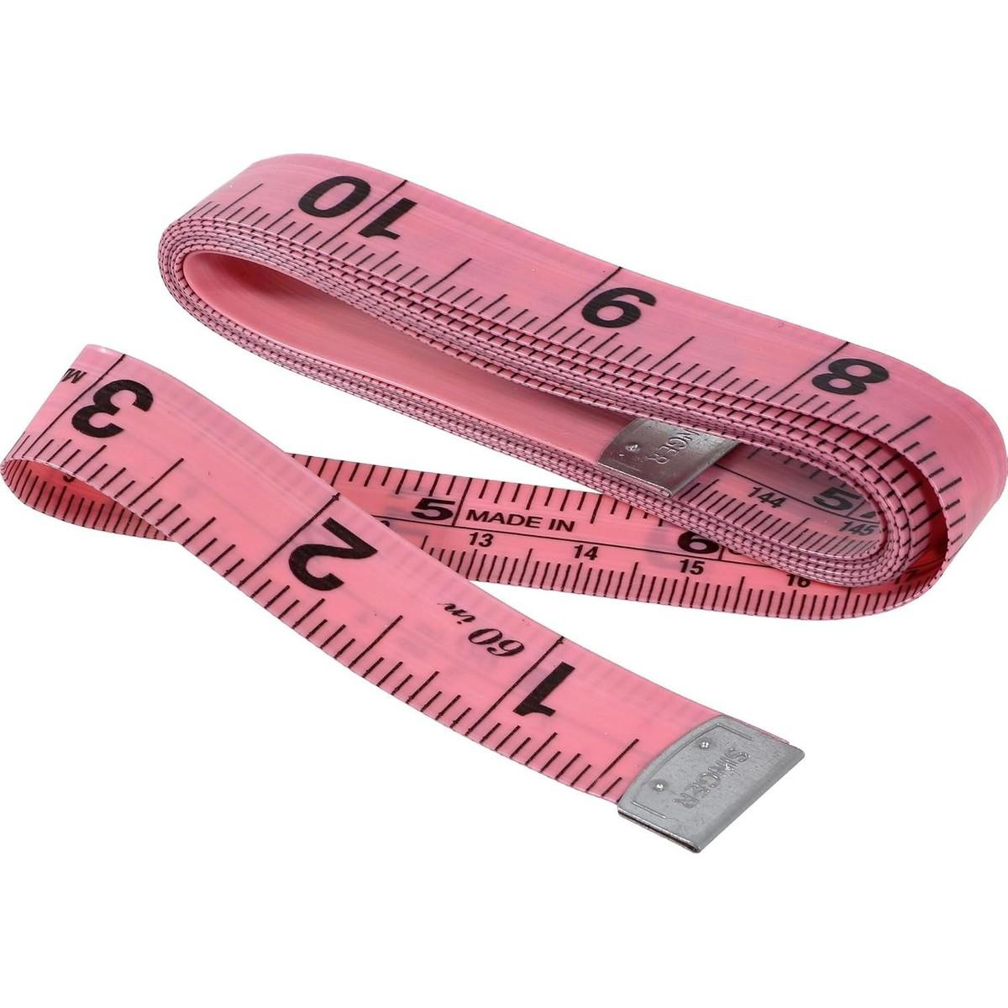
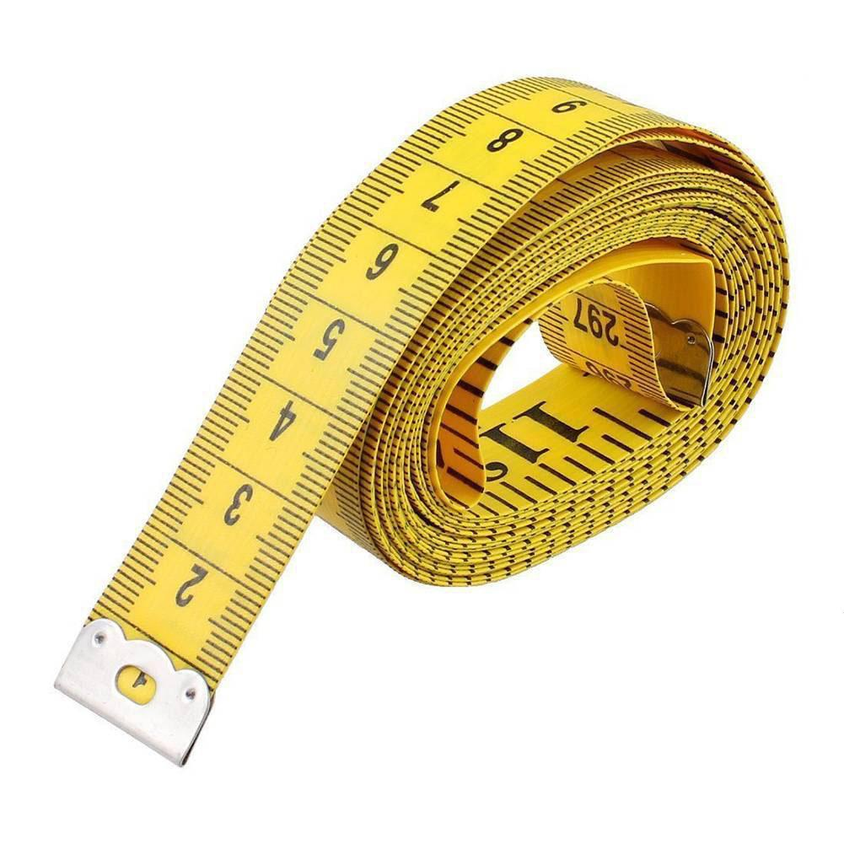
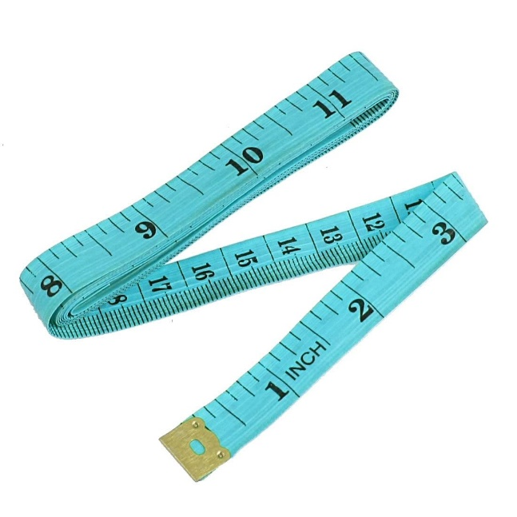
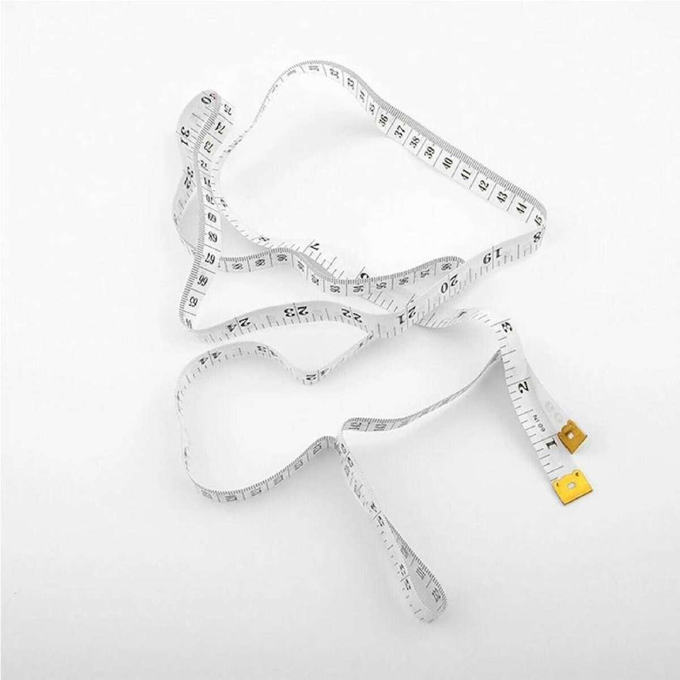
Description
A Flexible Tailor's Measuring Tape is made from cloth, fiberglass, or reinforced plastic. It bends easily around curved surfaces and body contours.
Features
- Soft and flexible
- Lightweight
- Double-sided markings
- Easily rolled for storage
Typical Length
- 150 cm (60 in)
Common Uses
- Tailoring
- Fashion design
- Body measurements
- Upholstery
- Crafts

3. Surveyor's Tape
# Source: AI Source: Provided by: [Data Path: Persons Table -> ID Column: 1, Name_En Column: Motasem Essam] -> From: [ChatGPT] on [7/17/2026]
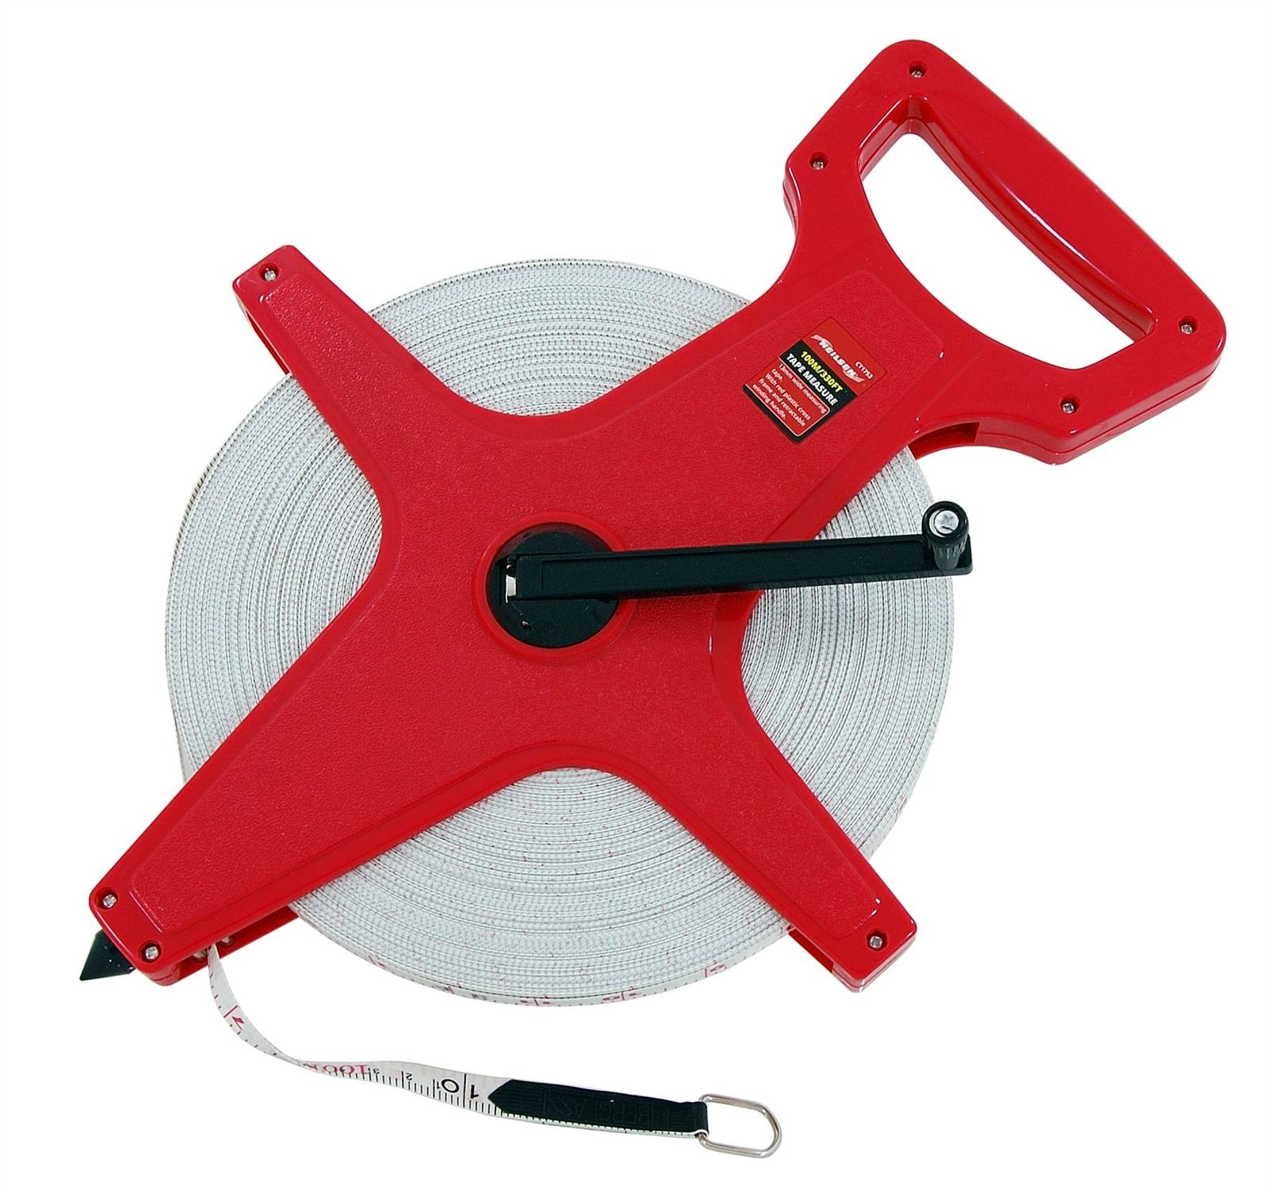
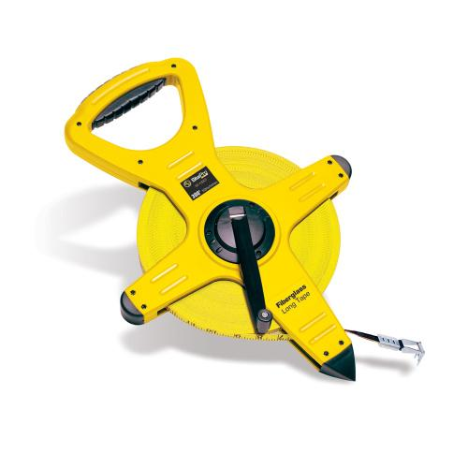
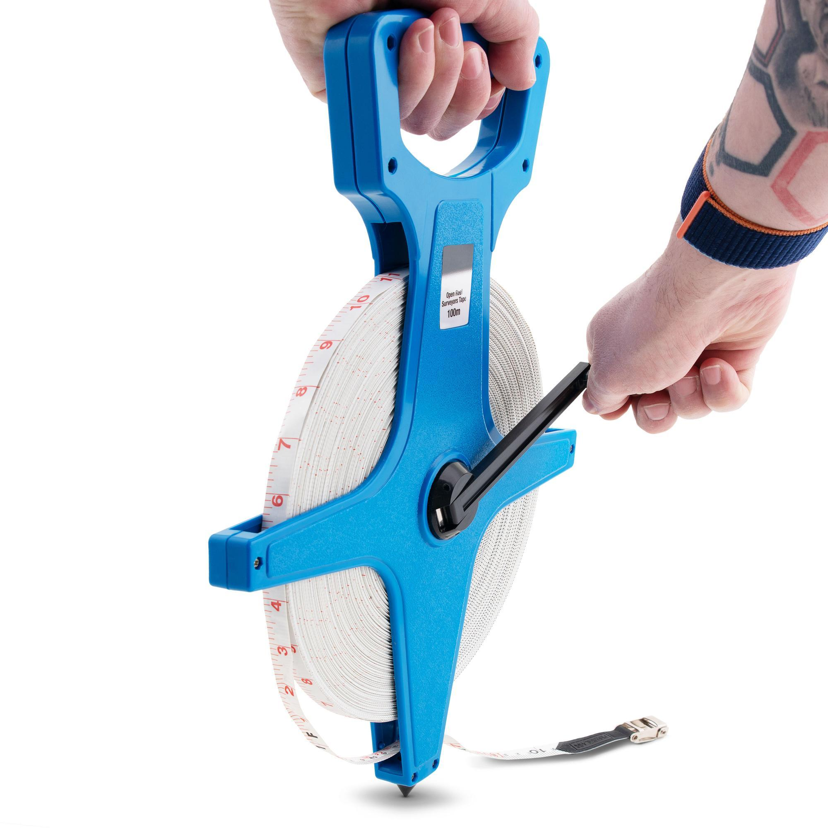
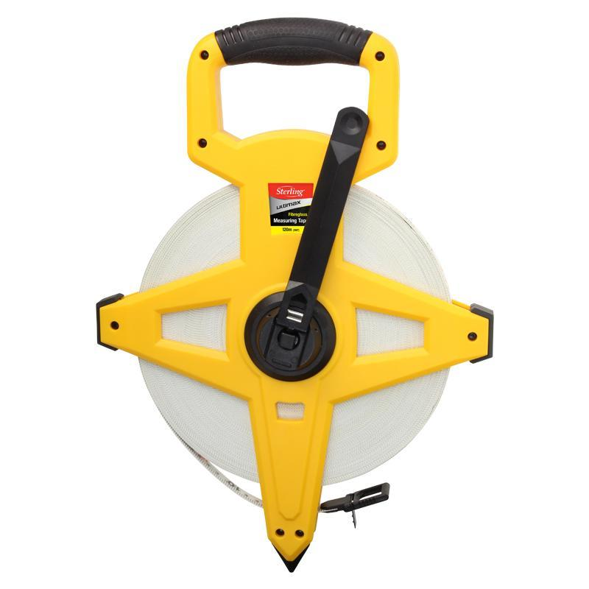
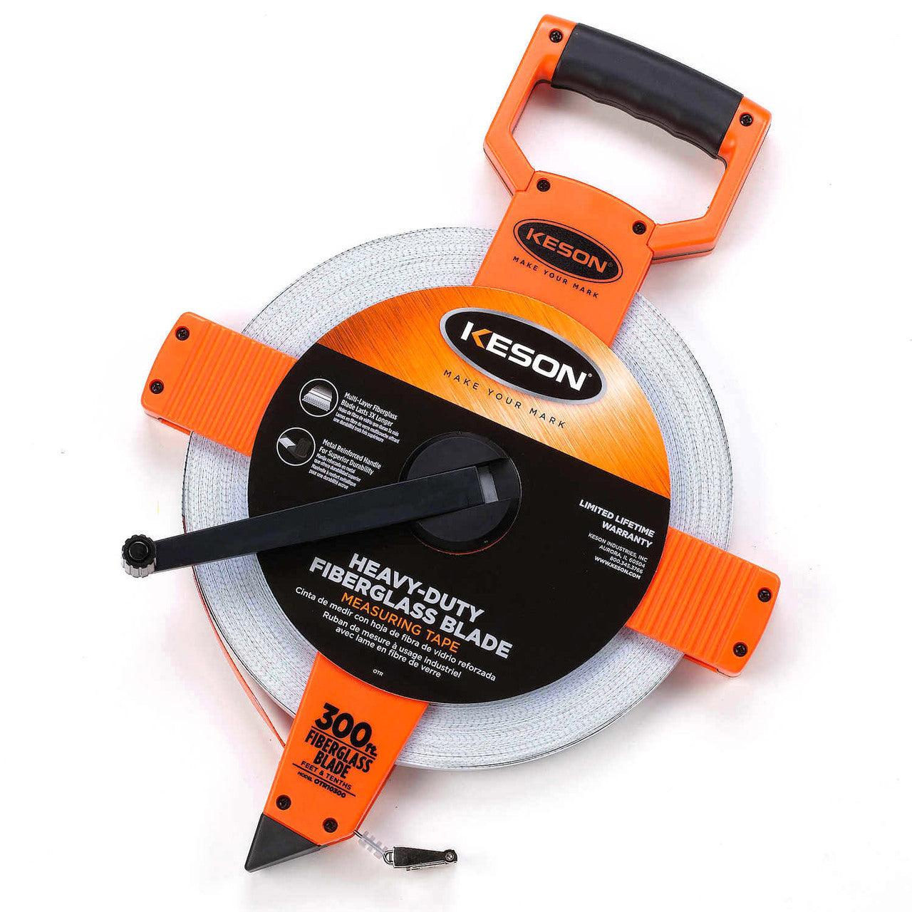

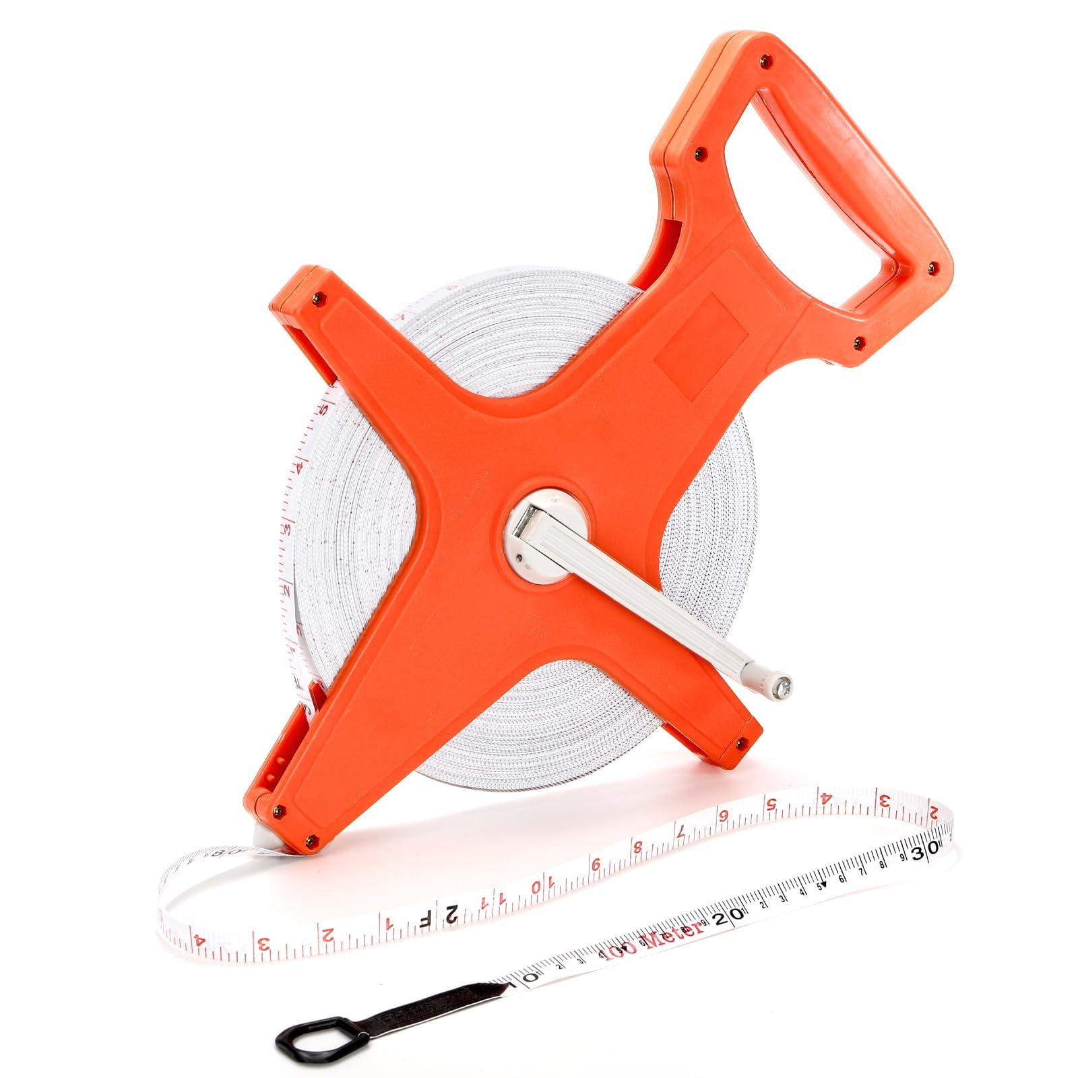
Description
A Surveyor's Measuring Tape is a long tape mounted on an open reel. It is designed for measuring long outdoor distances.
Features
- Open reel frame
- Hand crank
- Fiberglass or steel tape
- Weather resistant
Typical Length
- 30–100 m
- Sometimes up to 300 m
Common Uses
- Surveying
- Civil engineering
- Road construction
- Land measurement
- Agriculture

4. Long Steel Tape
# Source: AI Source: Provided by: [Data Path: Persons Table -> ID Column: 1, Name_En Column: Motasem Essam] -> From: [ChatGPT] on [7/17/2026]
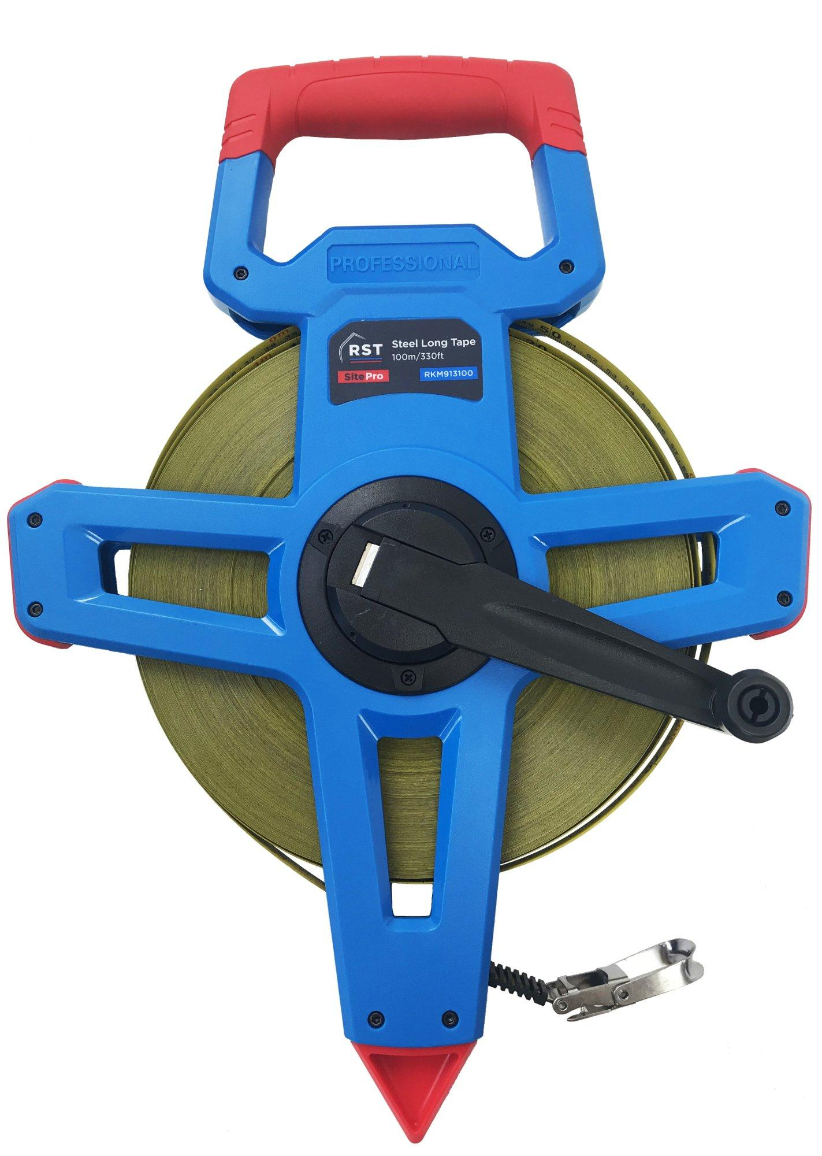
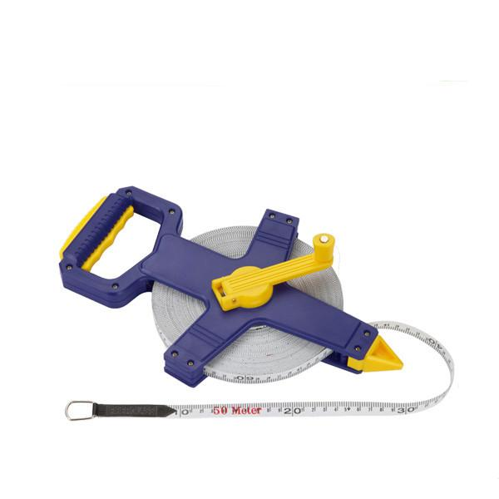
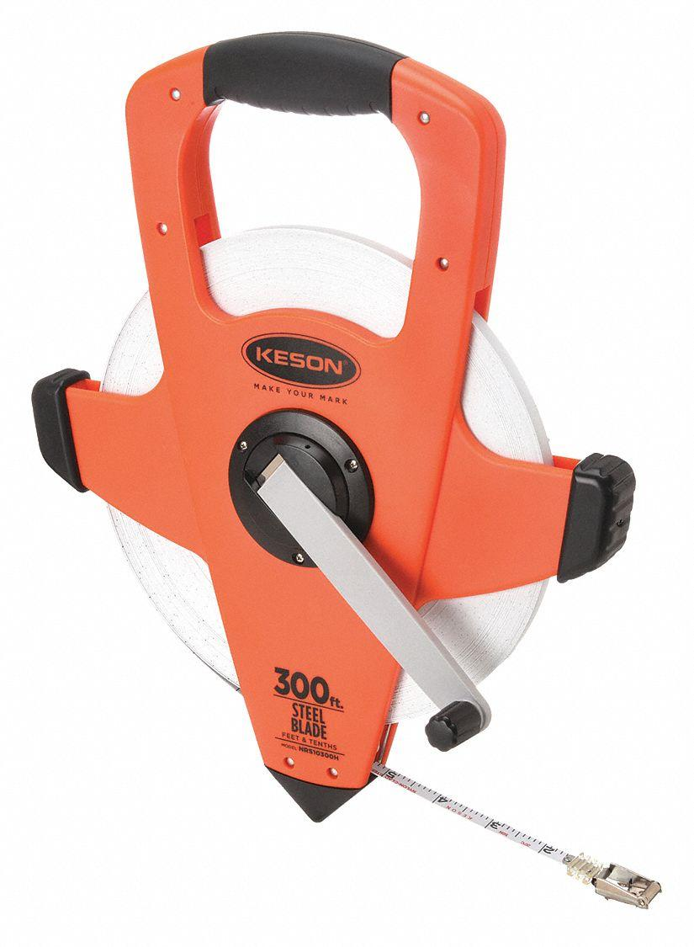
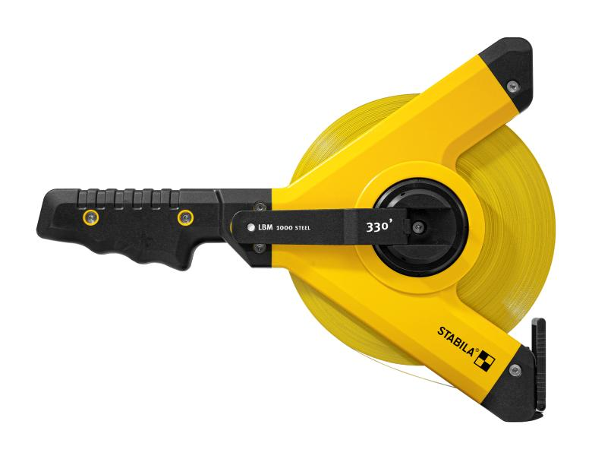
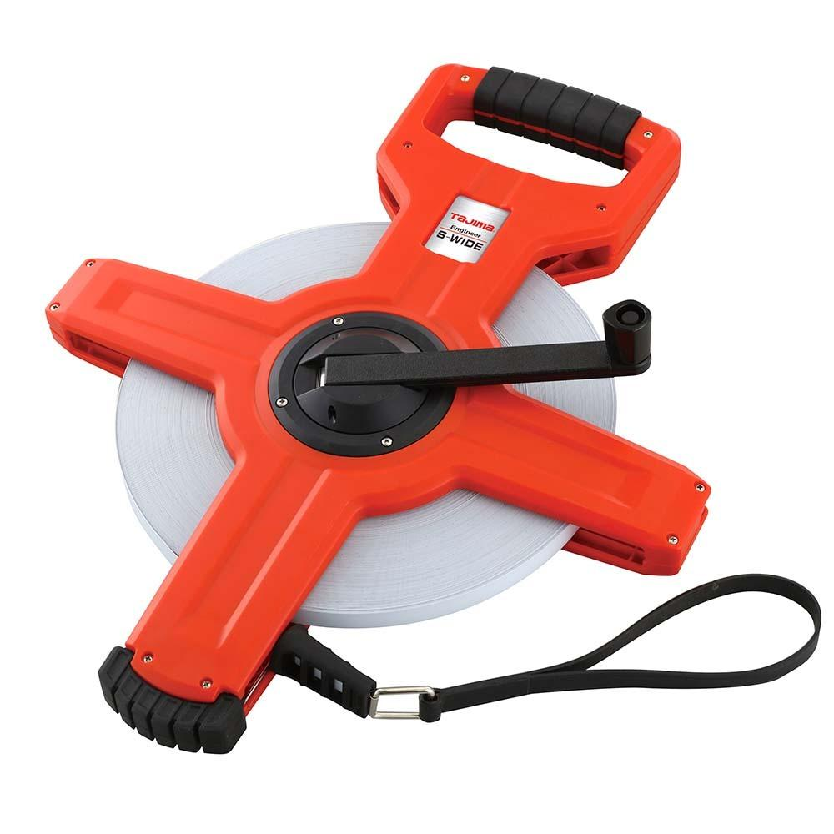
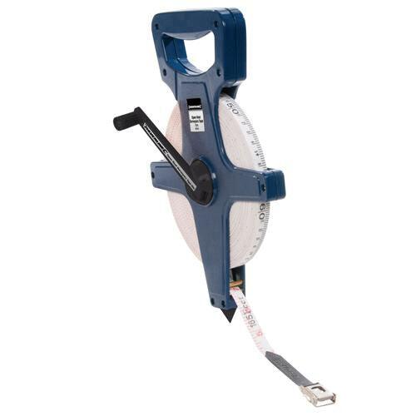

Description
A Long Steel Measuring Tape is a heavy-duty tape made entirely of steel for high accuracy over long distances.
Features
- Steel blade
- Minimal stretching
- High durability
- Accurate measurements
Typical Length
- 20–100 m
Common Uses
- Structural engineering
- Bridge construction
- Industrial measurement
- Precision field measurements

Comparison of Measuring Tape Types
# Source: AI Source: Provided by: [Data Path: Persons Table -> ID Column: 1, Name_En Column: Motasem Essam] -> From: [ChatGPT] on [7/17/2026]
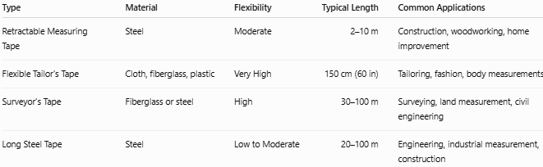
Type | Material | Flexibility | Typical Length | Common Applications
Retractable Measuring Tape | Steel | Moderate | 2–10 m | Construction, woodworking, home improvement
Flexible Tailor's Tape | Cloth, fiberglass, plastic | Very High | 150 cm (60 in) | Tailoring, fashion, body measurements
Surveyor's Tape | Fiberglass or steel | High | 30–100 m | Surveying, land measurement, civil engineering
Long Steel Tape | Steel | Low to Moderate | 20–100 m | Engineering, industrial measurement, construction

Measurement Units
# Source: AI Source: Provided by: [Data Path: Persons Table -> ID Column: 1, Name_En Column: Motasem Essam] -> From: [ChatGPT] on [7/17/2026]
Measuring tapes commonly include:
Metric Scale
- Millimeters (mm)
- Centimeters (cm)
- Meters (m)

Imperial Scale
- Inches (in)
- Feet (ft)
Many tapes display both metric and imperial units.

Common Lengths
# Source: AI Source: Provided by: [Data Path: Persons Table -> ID Column: 1, Name_En Column: Motasem Essam] -> From: [ChatGPT] on [7/17/2026]
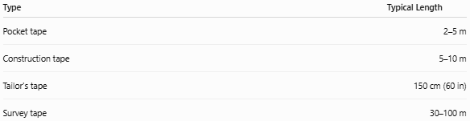
Type | Typical Length
Pocket tape | 2–5 m
Construction tape | 5–10 m
Tailor's tape | 150 cm (60 in)
Survey tape | 30–100 m

Least Count (Resolution)
# Source: AI Source: Provided by: [Data Path: Persons Table -> ID Column: 1, Name_En Column: Motasem Essam] -> From: [ChatGPT] on [7/17/2026]
The least count is the smallest graduation on the tape.
Typical values:
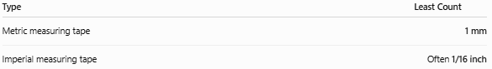
Type | Least Count
Metric measuring tape | 1 mm
Imperial measuring tape | Often 1/16 inch

How to Measure with a Measuring Tape
# Source: AI Source: Provided by: [Data Path: Persons Table -> ID Column: 1, Name_En Column: Motasem Essam] -> From: [ChatGPT] on [7/17/2026]
- Place the zero mark or hook at the starting point.
- Extend the tape along the object.
- Keep the tape straight (unless measuring a curved surface).
- Read the graduation at the end point.
- Record the measurement with the appropriate unit.

Example
# Source: AI Source: Provided by: [Data Path: Persons Table -> ID Column: 1, Name_En Column: Motasem Essam] -> From: [ChatGPT] on [7/17/2026]
If the object ends at:
2.37 m
the measured length is:
- 2.37 m
- 237 cm
- 2370 mm

Accuracy
# Source: AI Source: Provided by: [Data Path: Persons Table -> ID Column: 1, Name_En Column: Motasem Essam] -> From: [ChatGPT] on [7/17/2026]
A quality measuring tape typically provides measurements accurate to approximately ±1 mm over short distances. Accuracy depends on:
- Manufacturing quality
- Tape tension
- Hook condition
- Reading technique
- Temperature (for long steel tapes)

Sources of Error

Instrument Errors
# Source: AI Source: Provided by: [Data Path: Persons Table -> ID Column: 1, Name_En Column: Motasem Essam] -> From: [ChatGPT] on [7/17/2026]
- Bent tape
- Worn graduations
- Loose or damaged hook
- Stretched flexible tape

Observation Errors
# Source: AI Source: Provided by: [Data Path: Persons Table -> ID Column: 1, Name_En Column: Motasem Essam] -> From: [ChatGPT] on [7/17/2026]
- Parallax error
- Reading the wrong graduation
- Incorrect estimation

Positioning Errors
# Source: AI Source: Provided by: [Data Path: Persons Table -> ID Column: 1, Name_En Column: Motasem Essam] -> From: [ChatGPT] on [7/17/2026]
- Tape not fully straight
- Slack in the tape
- Incorrect zero alignment
- Measuring along an incorrect path

Environmental Errors
# Source: AI Source: Provided by: [Data Path: Persons Table -> ID Column: 1, Name_En Column: Motasem Essam] -> From: [ChatGPT] on [7/17/2026]
- Thermal expansion of steel tapes
- Wind affecting long survey tapes
- Dirt or debris on the tape

Applications
# Source: AI Source: Provided by: [Data Path: Persons Table -> ID Column: 1, Name_En Column: Motasem Essam] -> From: [ChatGPT] on [7/17/2026]
Measuring tapes are used in:
- Construction
- Civil engineering
- Mechanical engineering
- Surveying
- Architecture
- Interior design
- Carpentry
- Tailoring
- Manufacturing
- Home improvement

Advantages
# Source: AI Source: Provided by: [Data Path: Persons Table -> ID Column: 1, Name_En Column: Motasem Essam] -> From: [ChatGPT] on [7/17/2026]
A measuring tape:
- Measures long distances.
- Measures curved surfaces.
- Is flexible and portable.
- Supports both metric and imperial units.
- Is easy to store and transport.
- Is suitable for indoor and outdoor use.

Limitations
# Source: AI Source: Provided by: [Data Path: Persons Table -> ID Column: 1, Name_En Column: Motasem Essam] -> From: [ChatGPT] on [7/17/2026]
A measuring tape:
- Is less precise than a Vernier caliper or micrometer.
- Can sag over long spans if unsupported.
- May stretch with prolonged use (especially cloth tapes).
- Requires proper tension for accurate measurements.

Comparison with Other Length Measuring Instruments
# Source: AI Source: Provided by: [Data Path: Persons Table -> ID Column: 1, Name_En Column: Motasem Essam] -> From: [ChatGPT] on [7/17/2026]
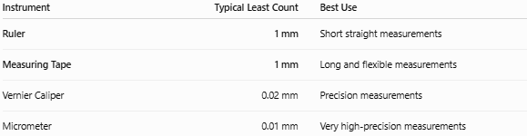
Instrument | Typical Least Count | Best Use
Ruler | 1 mm | Short straight measurements
Measuring Tape | 1 mm | Long and flexible measurements
Vernier Caliper | 0.02 mm | Precision measurements
Micrometer | 0.01 mm | Very high-precision measurements

Care and Maintenance
# Source: AI Source: Provided by: [Data Path: Persons Table -> ID Column: 1, Name_En Column: Motasem Essam] -> From: [ChatGPT] on [7/17/2026]
To maintain accuracy:
- Keep the tape clean and dry.
- Retract it gently to avoid damaging the hook.
- Avoid sharp bends or kinks.
- Store it in a dry environment.
- Replace tapes with damaged graduations or stretched sections.

Key Points
# Source: AI Source: Provided by: [Data Path: Persons Table -> ID Column: 1, Name_En Column: Motasem Essam] -> From: [ChatGPT] on [7/17/2026]
- A measuring tape is a flexible length-measuring instrument.
- It is ideal for long distances, large objects, and curved surfaces.
- It commonly measures in millimeters, centimeters, meters, inches, and feet.
- Typical least count is 1 mm (metric).
- It is widely used in construction, surveying, tailoring, engineering, and manufacturing.

Conclusion
# Source: AI Source: Provided by: [Data Path: Persons Table -> ID Column: 1, Name_En Column: Motasem Essam] -> From: [ChatGPT] on [7/17/2026]
A measuring tape is a versatile and flexible measuring instrument designed for accurately measuring linear dimensions, long distances, and curved surfaces. Available in retractable, tailor's, and surveyor's forms, it is indispensable across industries ranging from construction and engineering to tailoring and interior design. While it offers excellent portability and convenience, careful handling, proper alignment, and awareness of possible measurement errors are essential to obtain accurate and reliable results.

